**Web Technology  
theory assignment  
17-12-2020  
  
Rudrashis Kumar Dutta  
1906354**

**HR TAG**

<html>

    <head><title>HR Tag</title></head>

    <body>

        <p>Hello there!</p>

        <hr size="5" width="90%" color="#000000">

        <hr align="left" width="40%" noshade>

    </body>

</html>

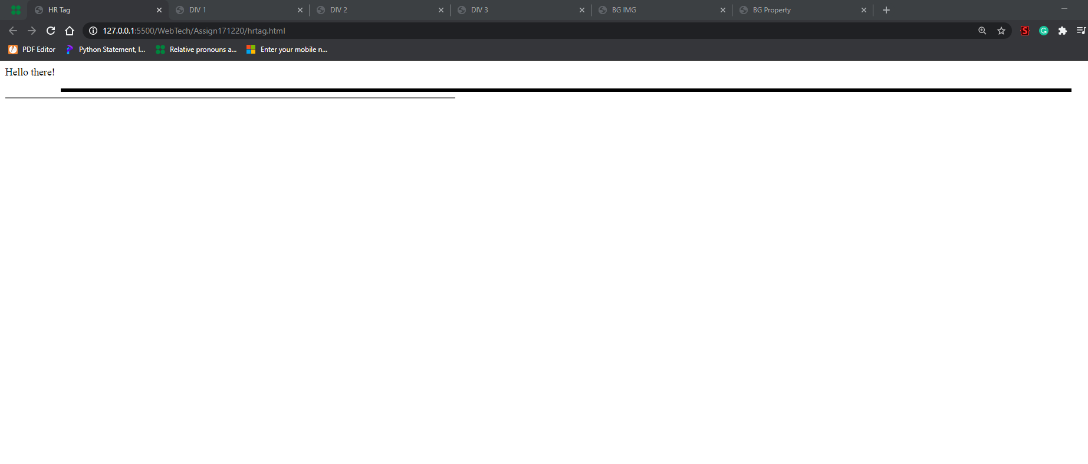

**DIV**

**1**

<html>

    <head><title>DIV 1</title></head>

    <body bgcolor="#000000" text="#ffffff">

        <p>Hello</p>

        <div style="background-color: crimson;">

            There!

        </div>

    </body>

</html>

**2**

<html>

    <head><title>DIV 2</title></head>

    <body>

        <br><br><br>

        <p>HELLO</p>

        <div style="font-size: xx-large;color: darkblue;">

            division:

            <p>HELLO</p>

        </div>

    </body>

</html>

**3**

<html>

    <head><title>DIV 3</title></head>

    <body>

        <p>HELLO</p>

        <div style="font-size: xx-large;font-family: monospace;background-color: black;text-align:right;color: burlywood;">

            <p>HELLO</p>

        </div>

    </body>

</html>

**1**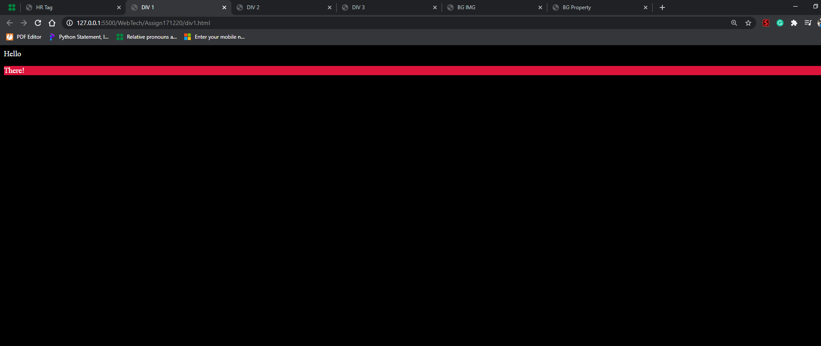

**2**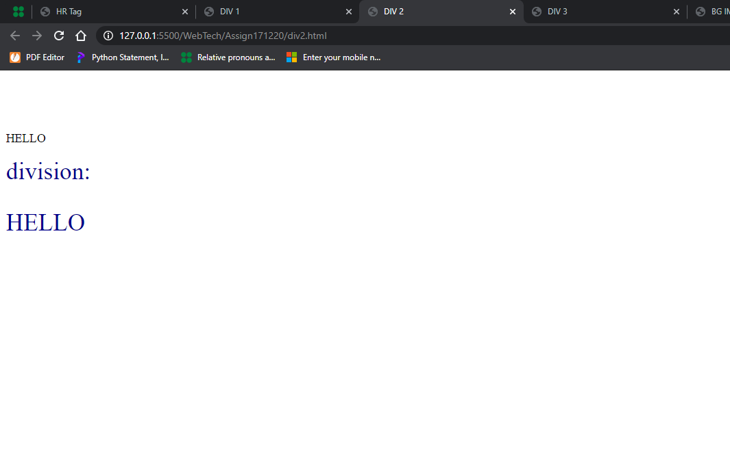

**3**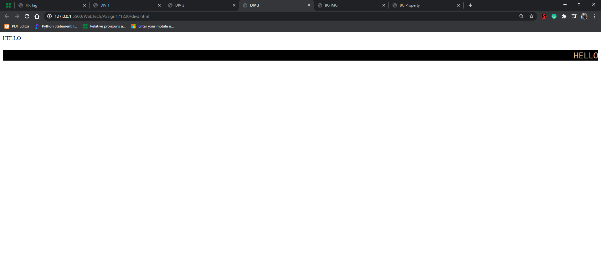

**BG IMG**

<html>

    <head><title>BG IMG</title></head>

    <body background="https://wallpaperaccess.com/full/1616123.jpg" style="background-size: cover;">

    </body>

</html>

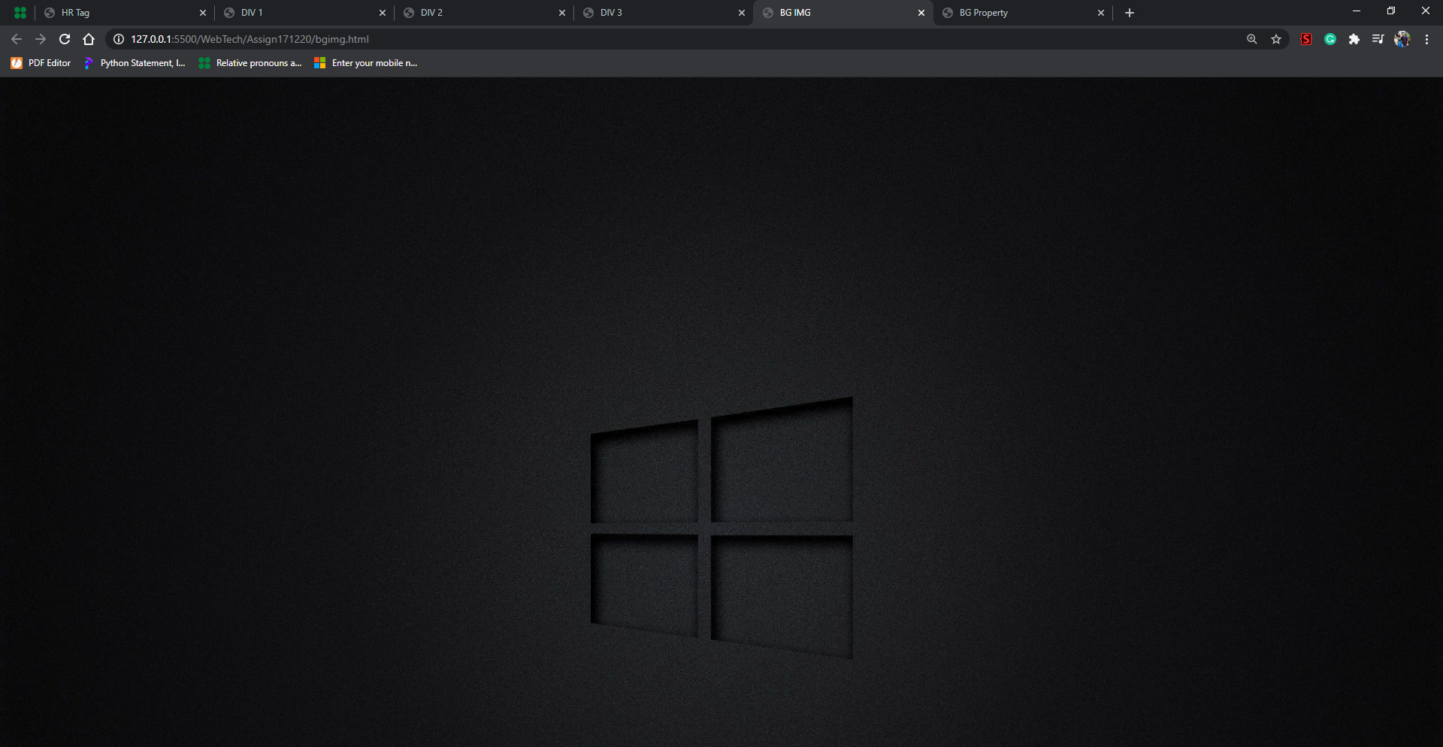

**BGProperty, Bottom Margin, Left Margin, Right Margin, Top margin**

<html>

    <head><title>BG Property</title></head>

    <body topmargin="10" bottommargin="20" leftmargin="20" rightmargin="20" bgcolor="#000000" style="color: honeydew;">

        HELLO

    </body>

</html>

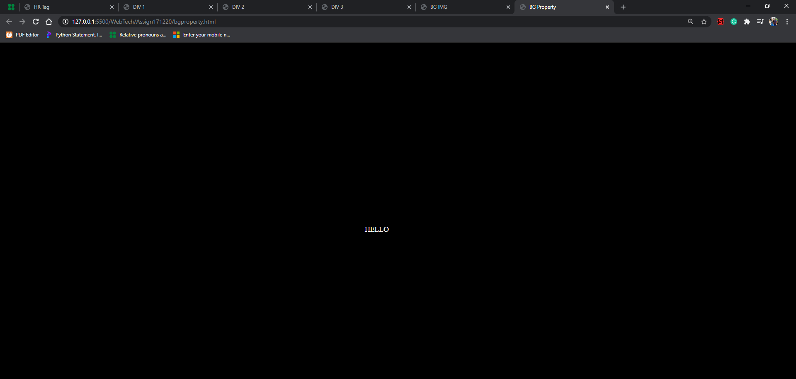

**BG Sound**

<html>

<head>

    <title>HTML Tag</title>

</head>

<body>

    <h2>HTML tag</h2>

    <bgsound src= "Song.mp3" >

</body>

</html>